CURRICULUM VITAE

**mohd. YUSUF**

**Add** **:Vill+Post Sultanpur Dost, Teh – Thakurdwara,**

**Dist Moradabad, UP 244001**

**Email ID : yusufmohd231@gmail.com**

**Contact : +917500072052**

**Objectives:**

To join an organization in a high growing industry that provide opportunities to learn and grow and attain highest of responsibility, where I can contribute to the growth of the company.

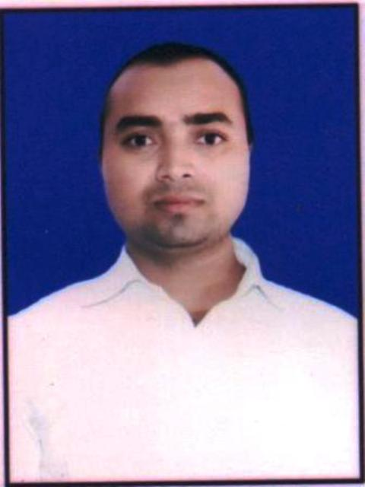**Educational Qualification:**

✪ B.A (MJPRU) Bareilly

✪ Intermediate from (U.P) Board

✪ Matriculation from (U.P) Board

✪ ‘O’ Level – Computer course from NIELIT

✪ ‘CCC’ – Computer course from NIELIT

✪ Accounting with Tally from INSTITUTE

✪ Electrician from DDU-GKY

**Computer proficiency:**

### Application Package : MS Office (Excel, World…) CorelDraw, Photoshop, Busy etc

Operating System : Windows XP / Windows 7/8/10s

Internet : Excellent Internet Proficiency

**wORKing experience:**

2017 – 2018, 1 YEAR Computer Operator ( Tally & Excel Accounting )

COMPANY NAME – Finesse Again, House no-7, Mg Road Sector-14, Gurgaon Haryana 122001

2020 – 2021 – Fiber Laser Marking & Computer Operator, Busy accounting

COMPANY NAME - Vijay Vallabh Metals Sahu Street,Moradabad, UP244001

**Personal Information:**

Date of birth : 11-03-1996

Father’s Name : Mohd.Yaqub

Marital status : Unmarried

Nationality : Indian

Sex : Male

Language known : Hindi & English

Interpersonal skills : Hardworking, honest & sincere

**I hereby declare that the above information furnished by me is true and correct to the best of my knowledge.**

**Place :- (MOHD.YUSUF)**

**Dated:-**